|  |  |
| --- | --- |
|  |  |
| SALES, PROFIT& TAX REPORT |  |
|  |  |
|  | April 9, 2023Data Warehousing &Data MiningPresented By: |
|  | **SP21-BCS-007 Asad Ali** **SP21-BCS-003 Asad Ur Rehman****SP21-BCS-017 Haroon Shahzad** |

|  |  |  |  |
| --- | --- | --- | --- |
|  |  |  |  |
|  | ITRODUCTIONThe purpose of this report is to present the design and implementation of a cube using Microsoft Analysis Services, and to demonstrate its utilization in various reporting and analytical tools such as Excel and Power BI. The cube has been designed with Sales and Profit Percentage as measures and Country as the dimension. The cube includes two types of sales and profit, one for internet sales and the other for resellers.Additionally, Tax % has been included as a measure to analyze the tax implications of sales and profits. The report presents the results of importing the cube into Excel and showcasing the data using pivot tables. Furthermore, the report demonstrates how the cube has been imported into Power BI to analyze sales and profit percentage by country. The report concludes with the presentation of a map graph in Excel that plots tax percentage by country.Overall, the report provides a comprehensive overview of the design, implementation, and utilization of a cube for analytical purposes, and highlights its importance in enabling decision-making processes by providing valuable insights into the data.TOOLS | |  |
|  |  |

|  |  |  |  |
| --- | --- | --- | --- |
|  |  |  |  |
|  | Cube Design with Measures and Dimension for Sales, Profit and Tax Analysis |  |  |
|  | THE CUBE INCLUDES This cube includes measures of Sales, Profit Percentage, and Tax Percentage, all analyzed within the context of the single Country dimension. The Country dimension allows for a comparison of performance between different sales territories, enabling identification of profit percentage and sales, for optimization. | |  |

|  |  |  |
| --- | --- | --- |
|  |  |  |
|  |
|  |

Reseller

A reseller is a business or individual who purchases products from a manufacturer or distributor and then sells them to end-users or consumers. Resellers can include wholesalers, retailers, and other intermediaries who help to distribute products to the end market. Resellers often purchase products in large quantities at discounted prices and then mark them up to make a profit.

Internet

In the context of business, the Internet is often used as a channel for e-commerce, which involves the buying and selling of products and services over the Internet. Companies can sell their products directly to customers through their own e-commerce websites, or they can use online marketplaces such as Amazon or eBay to reach a wider audience.

Sales

This measure refers to the total amount of revenue generated from sales transactions. It is a critical measure for analyzing the overall financial performance of the business. By tracking sales across different dimensions, such as country or product, you can gain insights into sales trends, patterns, and opportunities for growth.

Profit Percentage

This measure reflects the percentage of profit earned from the sales revenue. It is an important metric for evaluating the profitability of the business. By analyzing Profit Percentage across different dimensions, you can identify which products or sales territories are the most profitable and optimize your operations accordingly.

Tax Percentage

This measure is the percentage of tax charged on the sales revenue. It is a crucial measure for calculating the overall tax liability of the business. By analyzing Tax Percentage across different dimensions, you can identify which sales territories or products have the highest tax liability and optimize your tax planning and compliance efforts accordingly.

Hierarchies

In this cube, I have used a single dimension with a single hierarchy, which is "Dim Sales Territory" with the hierarchy "Countries". This approach enables us to analyze the measures at the country level and get an overview of how sales and profits are distributed across different countries.

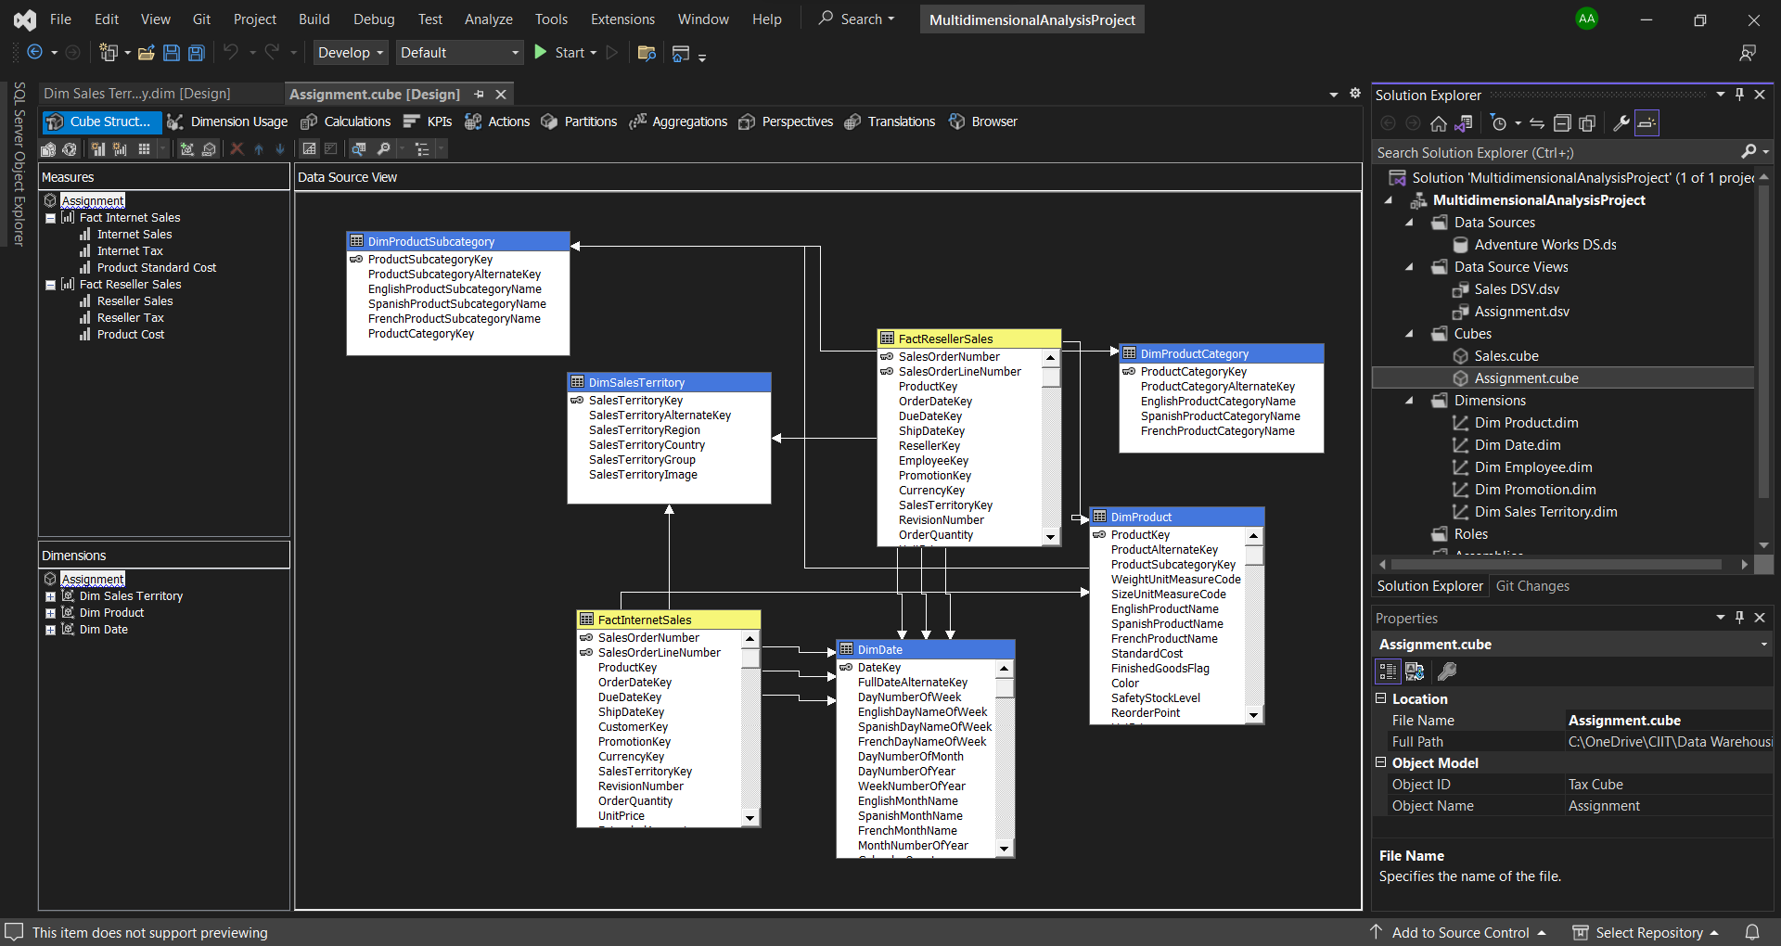

Calculated Measures

I have also included some calculated measures in my cube for more in depth and meaningful analysis of the business. MDX queries written for calculated measures are given below:

**Internet Sales Tax:**

([Measures].[Internet Tax]/[Measures].[Internet Sales])*100

**Reseller Sales Tax:**

([Measures].[Reseller Tax]/[Measures].[Reseller Sales])*100

**Internet Profit:**

(([Measures].[Internet Sales]-[Measures].[Product Standard Cost])/

[Measures].[Internet Sales])*100

**Reseller Profit:**

(([Measures].[Reseller Sales]-[Measures].[Product Cost])/[Measures].[Reseller Sales])*100

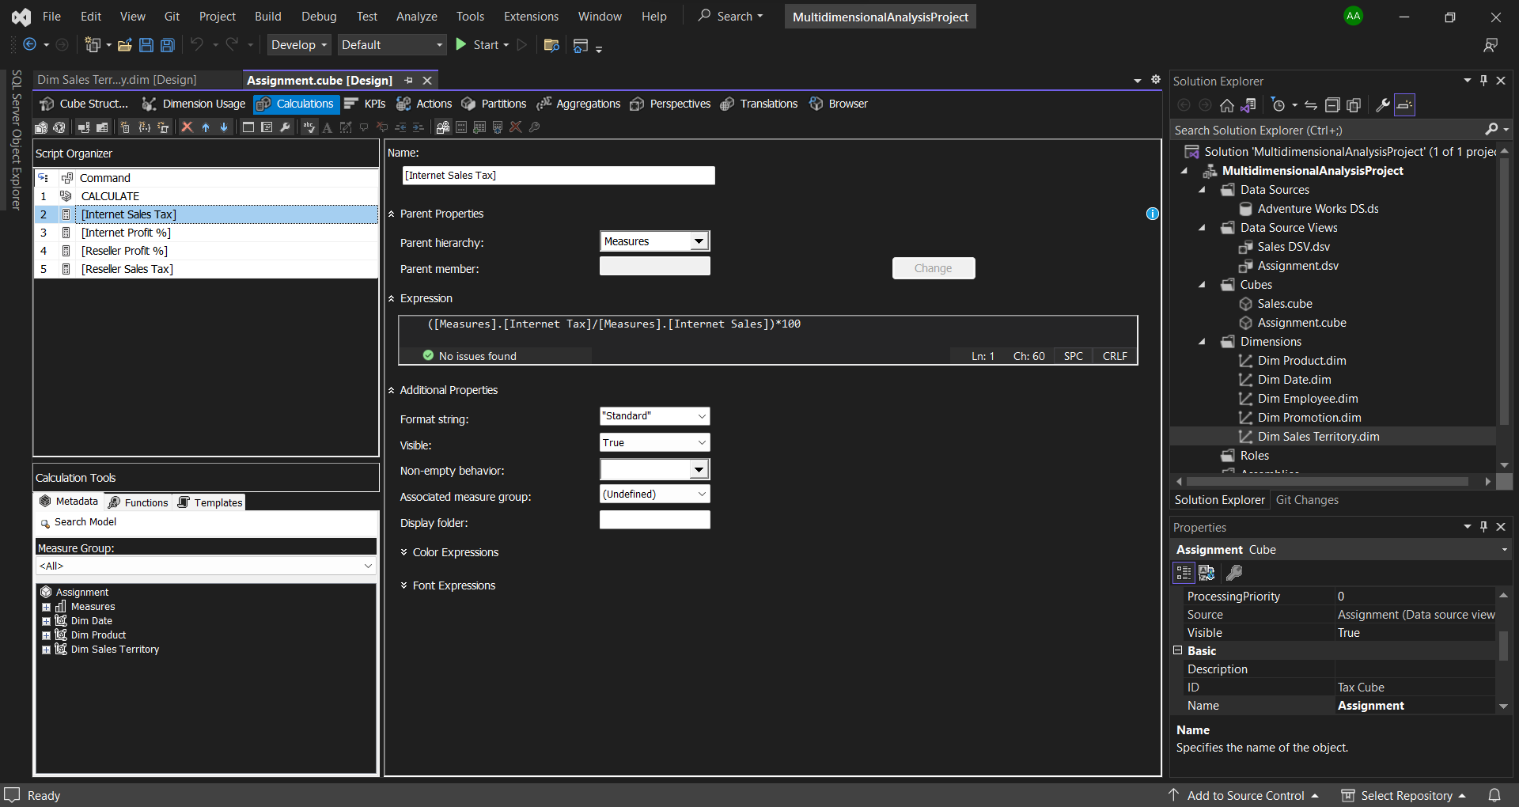

Sales Analysis

The Sales Analysis is a comprehensive examination of sales performance in different countries. In the cube, the sales measure is analyzed by country dimension. The analysis is further visualized through a bar chart in Power BI. The bar chart provides a quick and intuitive understanding of sales performance in different countries, enabling stakeholders to easily identify the countries with the highest and lowest sales performance. This analysis is critical in identifying trends and opportunities for improving sales performance and maximizing profitability.

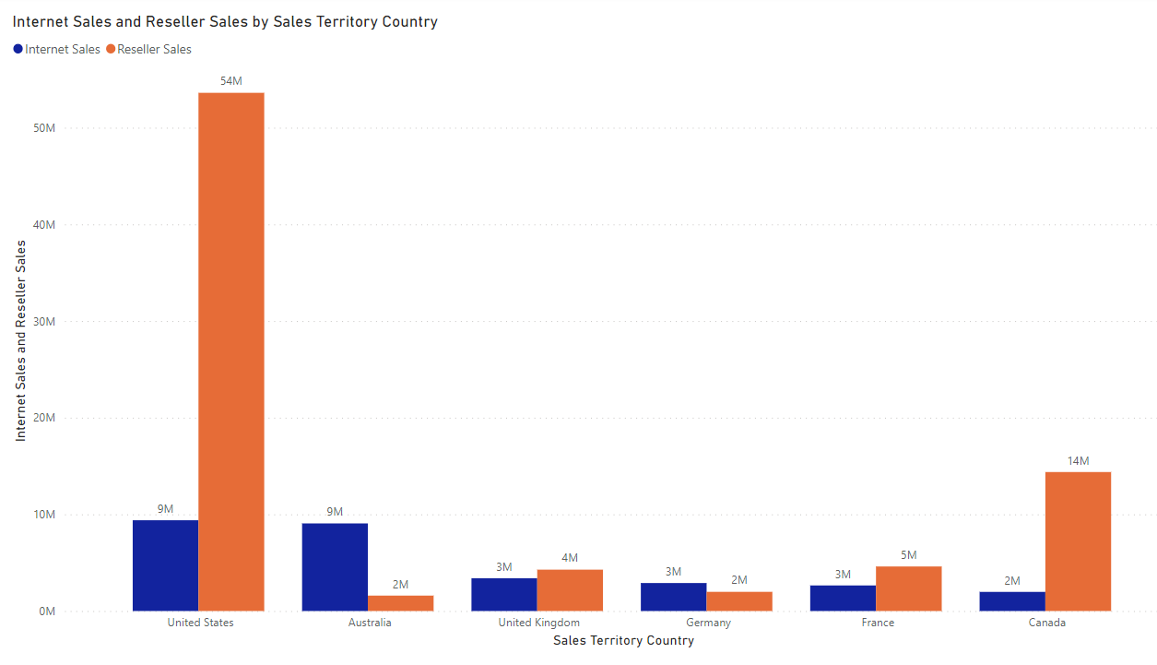

Insights

* We have our highest sales from United Sates and lowest sales number is from Germany
* In United Sates and Canada, we have very large Reseller distribution network while in all other countries either the Internet Sales dominates or equal to the Resellers Sales
* Our maximum sales come from Resellers
* All the revenue is coming from mostly one or two countries

Profit Analysis

The Profit Analysis is a thorough evaluation of the profit percentage in different countries. In the cube, the profit percentage measure is analyzed by country dimension. The analysis is visualized through a bar chart in Power BI, providing a clear picture of profit percentage in various countries. This visualization enables stakeholders to identify countries where profit margins are high and low, helping them to make informed decisions and take appropriate actions to improve profit margins. The Profit Analysis is a key component of the overall sales analysis and can provide valuable insights into the business's financial performance.

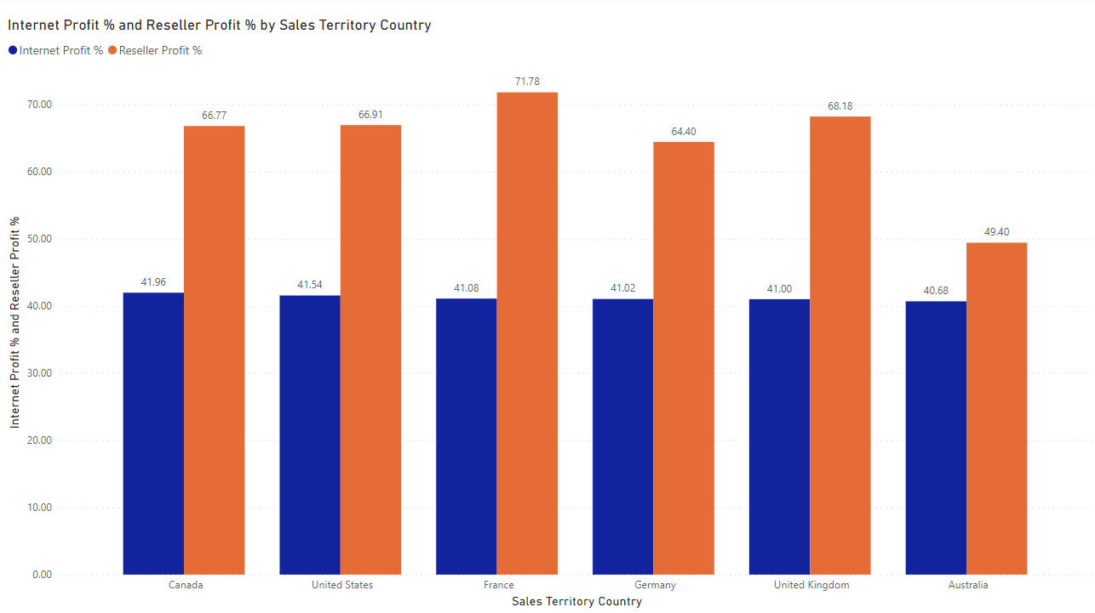

Insights

* Profit is almost constant over the Internet Sales
* Reseller Sales have different value of Profit Percentage in different Countries and highest Profit Percentage is 71 in France
* We have minimum Profit Percentage from Australia that is 49%
* Our Profit margins are very high we can invest more in marketing by reducing our gross margins

Tax Analysis

The tax analysis was performed using the Cube designed in the Microsoft Analysis Service Project. The analysis was performed by Country, and the results were displayed on a map chart in Excel. The map chart was created using the "Maps" feature in Excel, which allows us to plot data on a map based on geographic regions. The chart showed the tax percentage for each country, and the colors on the map were used to indicate the tax percentage ranges. This analysis provided valuable insights into the tax landscape across different countries and helped in identifying areas where tax planning and optimization could be done to improve business profitability.

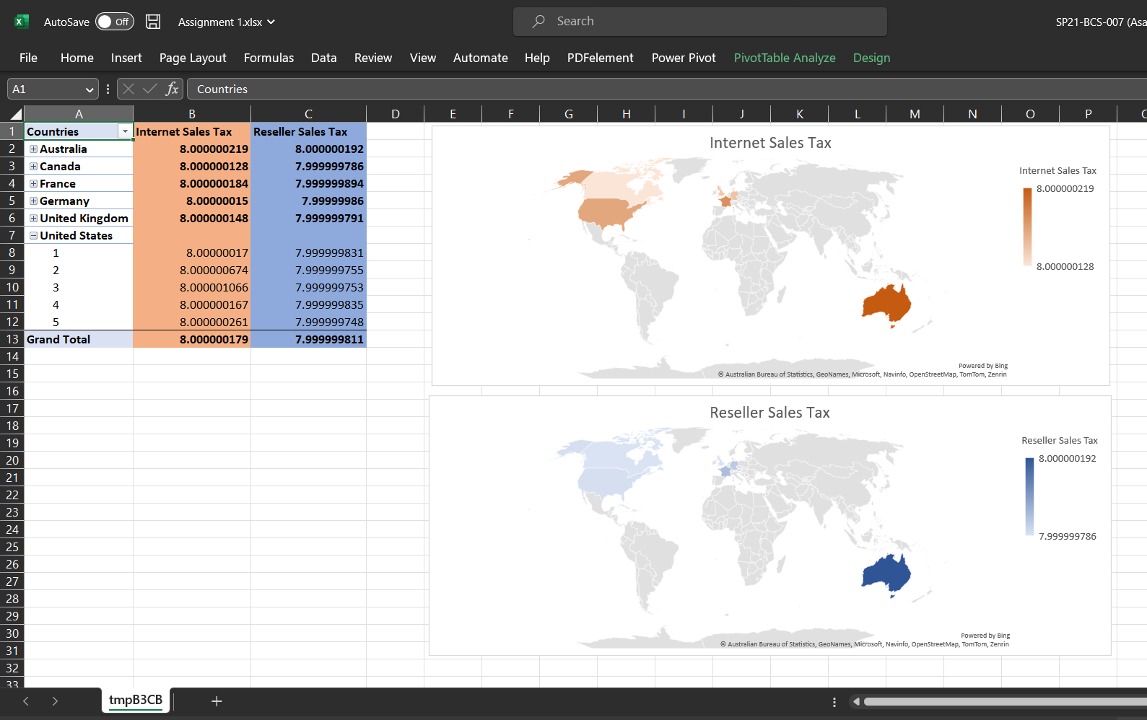

Insights

* We have constant Tax Rate over the Internet Sales and Reseller Sales in every country
* Relatively we are paying more tax in Australia
* Percentage is relatively less in Reseller Sales